Community Sports Facilities Booking System
Design, Implementation and Testing of a Web-Based Database Application

Module code and name: __________________________________
Student name: __________________________________
Student ID: __________________________________
Module leader: __________________________________
Submission date: __________________________________
Assignment No: 001

AI assistance declaration
OpenAI Codex assisted with code changes, SQL checks, automated testing, screenshots, report drafting and formatting. The student is responsible for reviewing the work, understanding the implementation and following the institution’s rules on permitted AI use.
Student signature: _________________________ Date: ______________

Table of Contents
Table of Contents 2
1. Introduction 4
1.1 Scope and assumptions 4
2. Specification of Database Relations 5
2.1 Relational Entity-Relationship Diagram 5
2.1.1 Relationships and cardinality 5
2.1.2 Normalisation 6
2.2 Data Dictionary 6
2.2.1 Member 6
2.2.2 FacilityType 6
2.2.3 Facility 7
2.2.4 Booking 7
2.2.5 Review 7
2.2.6 SportPreference 7
2.2.7 Inquiry 8
2.3 SQL Developer Data Modeler 8
3. Database Implementation 9
3.1 Data Models 9
3.2 Insert Statements 9
3.3 Select Queries 10
3.3.1 Bookings with member and facility names 11
3.3.2 Facilities available for a selected time 12
3.3.3 Average rating for each reviewed facility 13
3.3.4 Five least expensive facilities 14
3.3.5 Members who have made a booking 15
3.3.6 Facilities with no booking records 16
3.3.7 Preferred sports for each member 17
3.3.8 Latest guest inquiries 18
4. Implementation of the Web-Based Application 19
4.1 System Architecture 19
4.2 Home Page 19
4.3 Member Functionality 20
4.3.1 Sign In 20
4.3.2 Registration 21
4.3.3 Facility Search 24
4.3.4 Facility Booking 25
4.3.5 Review Submission 28
4.4 Guest Functionality 29
4.4.1 Restricted Search 29
4.4.2 Review Search 30
4.4.3 Membership Registration 31
4.4.4 Send Inquiry 31
5. Testing 34
5.1 Test Evidence 35
5.2 Summary of Testing 36
6. Further Discussion and Reflection 38
7. Conclusion 38
8. References 38
9. Appendices 40
Appendix A Full database schema 40
Member 40
FacilityType 40
Facility 40
Booking 40
Review 41
SportPreference 41
Inquiry 41
Appendix B Sample insert script 41
Appendix C Running and verifying the project 42
Appendix D Full controller code 42

1. Introduction
The Community Sports Facilities Booking System is a web application for a municipal sports council. It helps members find local venues and request a suitable time slot. The application checks existing bookings before saving a new request, so overlapping bookings can be rejected.
Registered members can sign in, record preferred sports, search facilities by sport, location, date and time, request bookings and review facilities after a confirmed visit. Guests can browse general availability, read reviews, register and send inquiries. Guests cannot create bookings or submit reviews.
The prototype uses Microsoft SQL Server, ASP.NET Core MVC with C#, Entity Framework Core and Razor views. The database contains Member, FacilityType, Facility, Booking, Review, SportPreference and Inquiry. SQL Developer Data Modeler was used for the supplied design. The report explains the database, implementation, SQL queries, testing and remaining limitations.

1.1 Scope and assumptions
A facility supports one booking for an overlapping time slot. Adjacent bookings are allowed when one ends exactly as another starts.
New bookings have Pending status. Confirmation is a manual database task because an administrative approval page is outside the prototype.
Reviews require a Confirmed booking whose end time is in the past. More than one review is currently allowed.
All dates and times use the server’s local time. Searches containing only a date show facilities with no active booking that day.
The prototype has no payment processing, email confirmation or password recovery. Passwords remain plain text and must be hashed before production use.

2. Specification of Database Relations

2.1 Relational Entity-Relationship Diagram
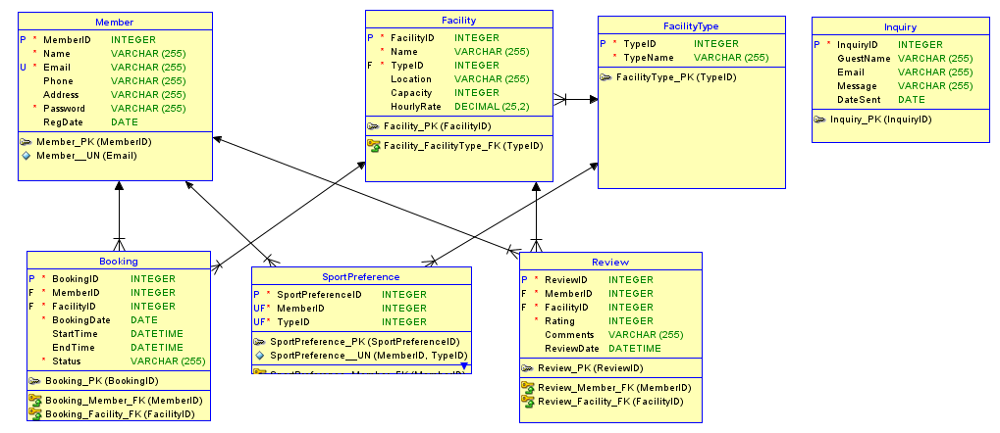
Figure 2.1. Relational model exported from SQL Developer Data Modeler.
The relational model contains seven entities. The diagram is consistent with the implemented relationships, including Booking to Member and Booking to Facility. SportPreference has its own primary key and a unique MemberID–TypeID pair. Inquiry is independent because a guest does not need a Member record.
Member. Stores each registered person’s name, email, contact details, password and registration date. Email is unique and is used for login.
FacilityType. Stores sport categories. Facilities and member preferences refer to a TypeID instead of repeating category names.
Facility. Stores venue name, sport category, location, capacity and hourly rate.
Booking. Links one member to one facility and stores the requested date, start time, end time and booking status.
Review. Links the author and facility and stores an integer rating from 1 to 5, comments and a review date.
SportPreference. Resolves the many-to-many relationship between members and sport categories. A member can choose several sports, but cannot select the same category twice.
Inquiry. Stores a guest’s name, email, message and date. It has no foreign key to Member.

2.1.1 Relationships and cardinality
Parent | Child | Cardinality
Facility | Review | One to many
Facility | Booking | One to many
FacilityType | Facility | One to many
FacilityType | SportPreference | One to many
Member | Review | One to many
Member | SportPreference | One to many
Member | Booking | One to many

Every child foreign key is required. One parent can have no related child records or many of them; every child row refers to exactly one parent. SportPreference turns the many-to-many association into two one-to-many relationships.

2.1.2 Normalisation
The design separates different subjects into their own tables. In first normal form, each column holds a single value, and preferred sports are represented by separate SportPreference rows. The non-key attributes describe their table’s key rather than only part of a composite candidate key, supporting second normal form. FacilityType holds the sport name once, while Facility and SportPreference hold its ID, avoiding a repeated type name and supporting third normal form.

2.2 Data Dictionary
The following tables describe the inspected SQL Server schema after reconciliation. Existing VARCHAR(255) lengths and DECIMAL(25,2) rates are retained to avoid truncating saved data. Earlier narrower lengths in the draft did not describe the actual database. Blank optional values are permitted only where NULL is shown.

2.2.1 Member
Attribute | SQL type | Key and constraints | Description
MemberID | INT | NOT NULL; IDENTITY; PK | Member identifier
Name | VARCHAR(255) | NOT NULL | Name
Email | VARCHAR(255) | NOT NULL; UNIQUE | Email address
Phone | VARCHAR(255) | NULL allowed | Contact number
Address | VARCHAR(255) | NULL allowed | Postal address
Password | VARCHAR(255) | NOT NULL | Prototype login password
RegDate | DATE | NULL allowed | Registration date

2.2.2 FacilityType
Attribute | SQL type | Key and constraints | Description
TypeID | INT | NOT NULL; IDENTITY; PK | Sport category identifier
TypeName | VARCHAR(255) | NOT NULL | Sport category

2.2.3 Facility
Attribute | SQL type | Key and constraints | Description
FacilityID | INT | NOT NULL; IDENTITY; PK | Facility identifier
Name | VARCHAR(255) | NOT NULL | Name
TypeID | INT | NOT NULL; FK to FacilityType | Sport category identifier
Location | VARCHAR(255) | NULL allowed | Venue location
Capacity | INT | NULL allowed | Maximum participants
HourlyRate | DECIMAL(25,2) | NULL allowed | Rate in LKR per hour

2.2.4 Booking
Attribute | SQL type | Key and constraints | Description
BookingID | INT | NOT NULL; IDENTITY; PK | Booking identifier
MemberID | INT | NOT NULL; FK to Member | Member identifier
FacilityID | INT | NOT NULL; FK to Facility | Facility identifier
BookingDate | DATE | NOT NULL | Requested date
StartTime | DATETIME | NULL allowed | Start date and time
EndTime | DATETIME | NULL allowed | End date and time
Status | VARCHAR(255) | NOT NULL; CHECK allowed statuses | Pending, Confirmed or Cancelled

2.2.5 Review
Attribute | SQL type | Key and constraints | Description
ReviewID | INT | NOT NULL; IDENTITY; PK | Review identifier
MemberID | INT | NOT NULL; FK to Member | Member identifier
FacilityID | INT | NOT NULL; FK to Facility | Facility identifier
Rating | INT | NOT NULL; CHECK 1–5 | Whole number from 1 to 5
Comments | VARCHAR(255) | NULL allowed | Written feedback
ReviewDate | DATETIME | NULL allowed | Feedback date and time

2.2.6 SportPreference
Attribute | SQL type | Key and constraints | Description
SportPreferenceID | INT | NOT NULL; IDENTITY; PK | Preference identifier
MemberID | INT | NOT NULL; Unique pair with TypeID; FK to Member | Member identifier
TypeID | INT | NOT NULL; Unique pair with MemberID; FK to FacilityType | Sport category identifier

2.2.7 Inquiry
Attribute | SQL type | Key and constraints | Description
InquiryID | INT | NOT NULL; IDENTITY; PK | Inquiry identifier
GuestName | VARCHAR(255) | NULL allowed | Guest sender
Email | VARCHAR(255) | NULL allowed | Email address
Message | VARCHAR(255) | NULL allowed | Inquiry text
DateSent | DATE | NULL allowed | Inquiry date

2.3 SQL Developer Data Modeler
The supplied design is saved as ER.dmd with its ER model folder. The original logical diagram was engineered into a relational model. The relational export in Figure 2.1 shows the final seven-table design and foreign keys. The saved DDL identifies SQL Developer Data Modeler 24.3.1.351.0831 and a SQL Server 2012 generation target. This is a DDL target setting, not a claim about the installed SQL Server version.
-- Generated by Oracle SQL Developer Data Modeler 24.3.1.351.0831
-- at: 2026-08-27 18:17:18 IST
-- site: SQL Server 2012
-- type: SQL Server 2012

The generated script was checked against SQL Server metadata. The supplied DDL text omitted Booking_Member_FK even though the relational diagram showed it; the running database contains that foreign key. Review.Rating was still VARCHAR in the running database. It was converted to INT after checking every saved value, and database CHECK constraints were added for Rating and Status. Appendix A therefore records the reconciled database rather than repeating an outdated generated script.
The original logical export is an earlier draft: it lacks SportPreferenceID and has relationship lines that do not fully match the physical schema. Figure 2.1 and the relationship table above define the implemented design. The saved project, original exports and reconciled DDL are retained as design evidence.

3. Database Implementation

3.1 Data Models
SQL Server stores all seven tables. Primary keys use IDENTITY(1,1), foreign keys preserve references, Member.Email is unique and the SportPreference pair is unique. EF Core maps BookingID as database-generated and MemberID as a supplied foreign key. The previous mapping reversed these settings; the corrected mapping allows a new booking to receive its own identifier.
entity.Property(e => e.BookingId).ValueGeneratedOnAdd();
entity.Property(e => e.MemberId).ValueGeneratedNever();

Tables can be created in dependency order: Member and FacilityType, then Facility, followed by Booking, Review and SportPreference. Inquiry has no dependencies. Appendix A contains the complete executable CREATE TABLE script extracted from the inspected schema.
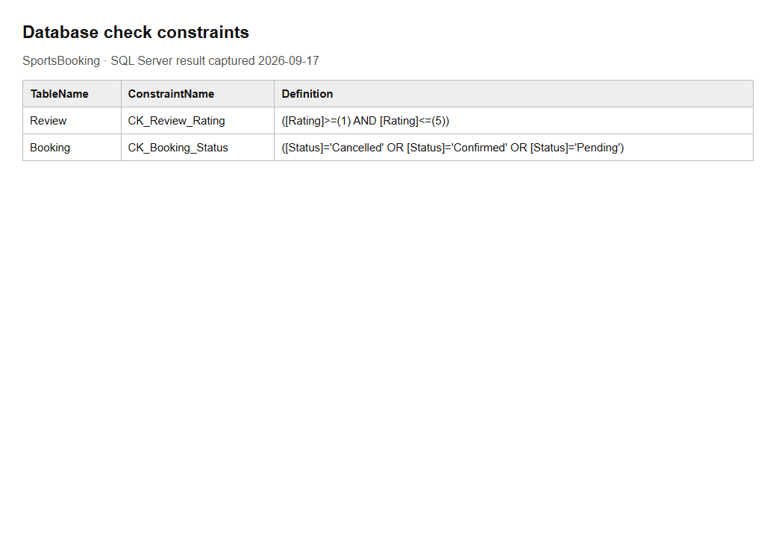
Figure 3.1. Actual SQL Server CHECK constraint metadata, displayed as a result table.

3.2 Insert Statements
The database already contains representative sample records. The captured counts below exclude the temporary records created for testing and screenshots. Existing data includes duplicate facility names with different IDs, so relationships and queries use IDs rather than assuming names are unique.
Table | Saved rows
Member | 8
FacilityType | 5
Facility | 18
Booking | 15
Review | 20
SportPreference | 15
Inquiry | 8

Appendix B provides a standalone example that inserts into every table in dependency order. SCOPE_IDENTITY() captures each new key instead of assuming IDs begin at 1. The example is intended to be run once in a test database; it was not added to the existing database. Successful application inserts are demonstrated by the captured Member, SportPreference, Booking, Review and Inquiry rows in Section 4.
INSERT INTO Facility (Name, TypeID, Location, Capacity, HourlyRate)
VALUES ('Sample Tennis Court', @TypeID, 'Negombo', 4, 1500.00);
DECLARE @FacilityID INT = SCOPE_IDENTITY();

3.3 Select Queries
Eight queries were executed against SportsBooking. Each result image displays the actual returned rows in a readable table; these are captured query outputs, not screenshots of SQL Server Management Studio. No passwords are selected. The availability example uses 17 October 2026, 10:00–11:00.

3.3.1 Bookings with member and facility names
This three-table join replaces raw foreign keys with readable member and facility names for a booking list.
SELECT TOP (10) b.BookingID,m.Name AS Member,f.Name AS Facility,b.BookingDate,b.Status
FROM Booking b
JOIN Member m ON b.MemberID=m.MemberID
JOIN Facility f ON b.FacilityID=f.FacilityID
ORDER BY b.BookingID;

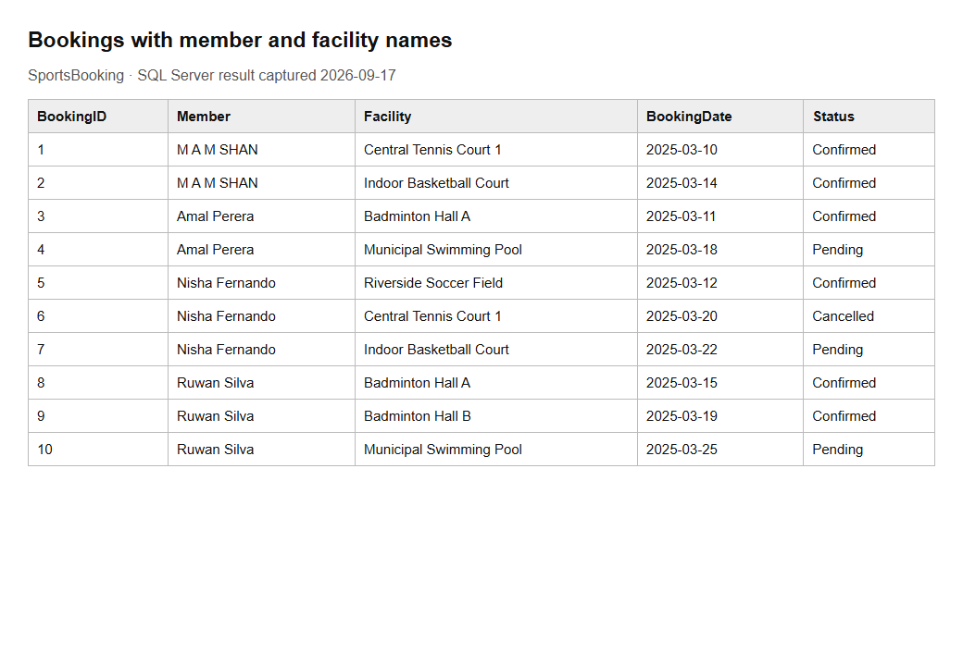
Figure 3.2. Query 1 returned 10 rows.

3.3.2 Facilities available for a selected time
The NOT EXISTS condition excludes overlapping Pending or Confirmed bookings. Cancelled bookings do not block a slot. Missing times are treated as blocking the requested day.
SELECT f.FacilityID,f.Name,f.Location
FROM Facility f
WHERE NOT EXISTS (SELECT 1
FROM Booking b
WHERE b.FacilityID=f.FacilityID AND b.BookingDate='2026-10-17' AND b.Status<>'Cancelled' AND
(b.StartTime IS NULL OR b.EndTime IS NULL OR (b.StartTime<'2026-10-17T11:00:00' AND
b.EndTime>'2026-10-17T10:00:00')))
ORDER BY f.FacilityID;

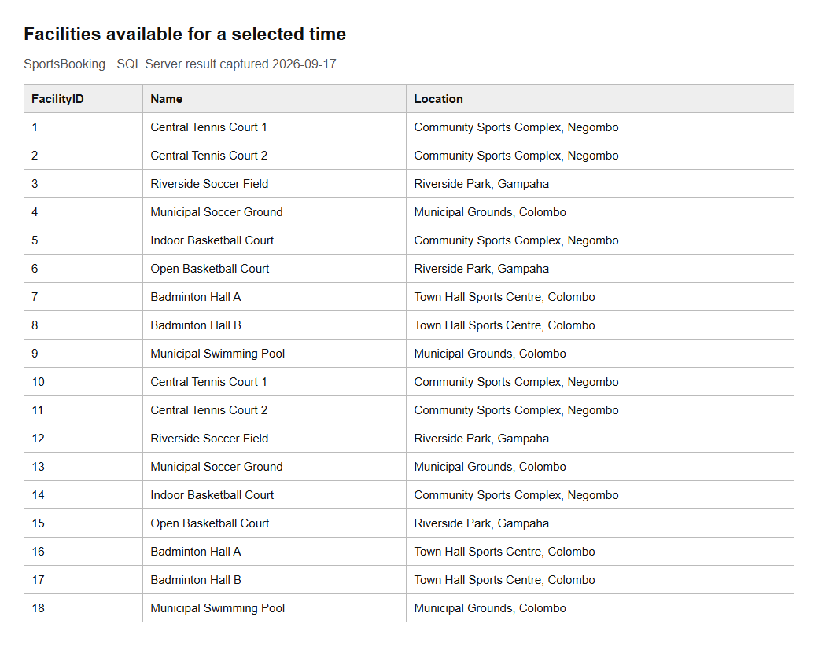
Figure 3.3. Query 2 returned 18 rows.

3.3.3 Average rating for each reviewed facility
GROUP BY produces one row per reviewed facility. Casting before AVG prevents integer division from hiding fractional averages.
SELECT f.Name,COUNT(*) AS Reviews,CAST(AVG(CAST(r.Rating AS DECIMAL(5,2))) AS DECIMAL(5,2)) AS
AverageRating
FROM Review r
JOIN Facility f ON r.FacilityID=f.FacilityID
GROUP BY f.FacilityID,f.Name
ORDER BY AverageRating DESC;

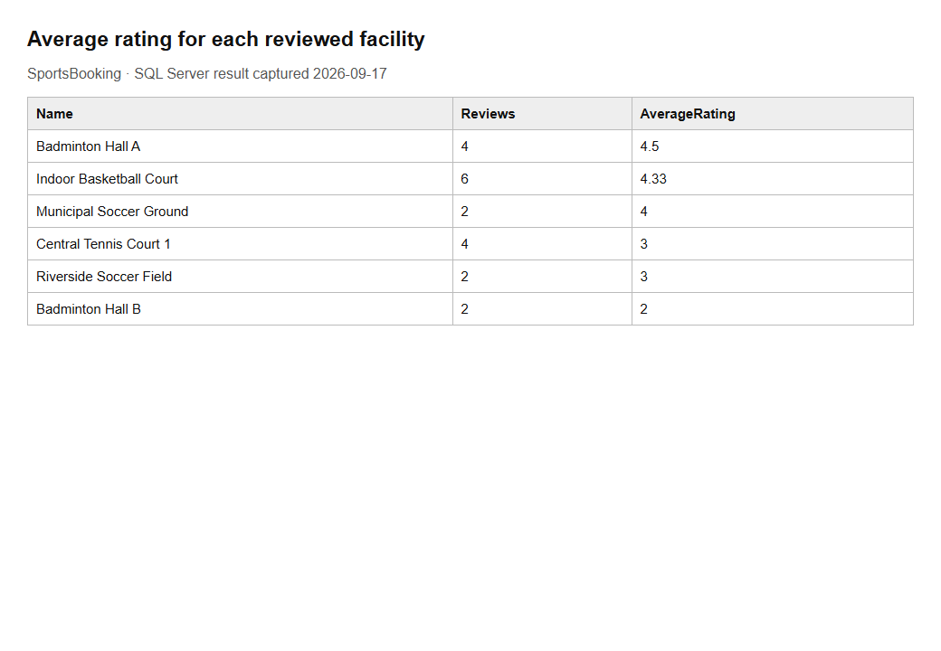
Figure 3.4. Query 3 returned 6 rows.

3.3.4 Five least expensive facilities
TOP and ORDER BY list five venues with the lowest known hourly rates. FacilityID breaks equal-price ties.
SELECT TOP (5) Name,Location,HourlyRate
FROM Facility
WHERE HourlyRate IS NOT NULL
ORDER BY HourlyRate,FacilityID;

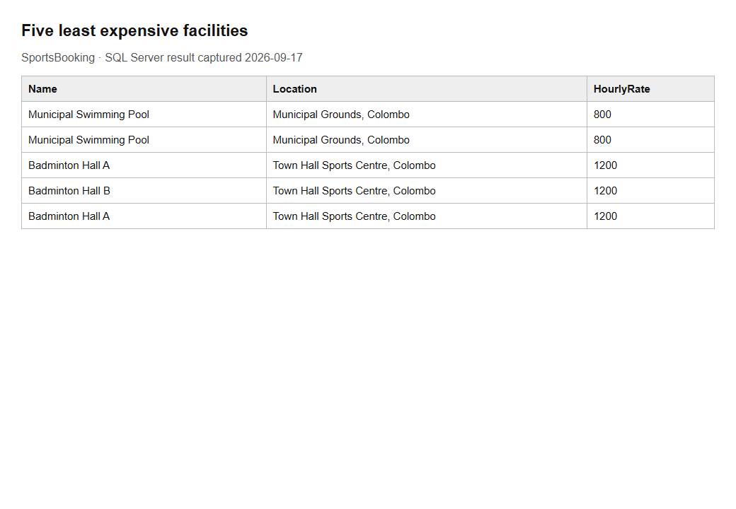
Figure 3.5. Query 4 returned 5 rows.

3.3.5 Members who have made a booking
The subquery finds members with at least one booking, without duplicating a member who has several bookings.
SELECT MemberID,Name
FROM Member
WHERE MemberID IN (SELECT MemberID
FROM Booking)
ORDER BY MemberID;

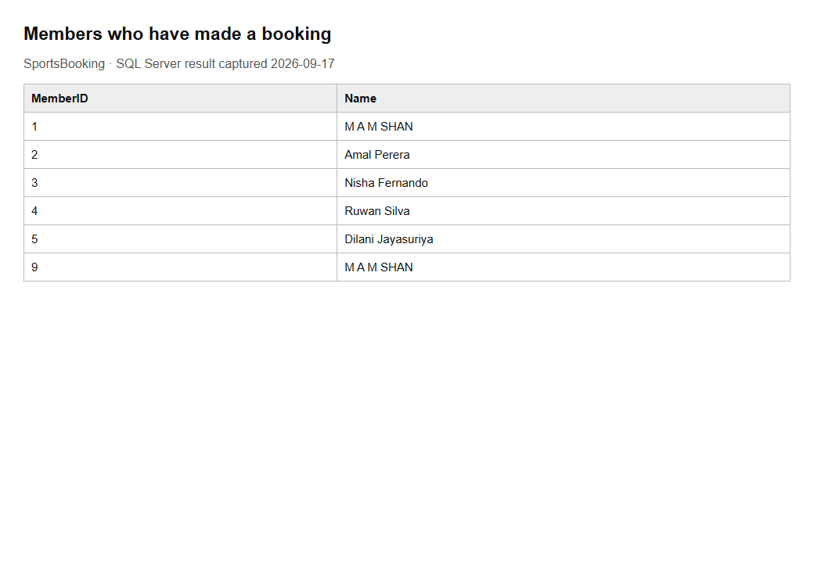
Figure 3.6. Query 5 returned 6 rows.

3.3.6 Facilities with no booking records
LEFT JOIN retains facilities even when there is no matching booking. Testing for a null booking ID identifies unused facilities.
SELECT f.FacilityID,f.Name
FROM Facility f
LEFT
JOIN Booking b ON f.FacilityID=b.FacilityID
WHERE b.BookingID IS NULL
ORDER BY f.FacilityID;

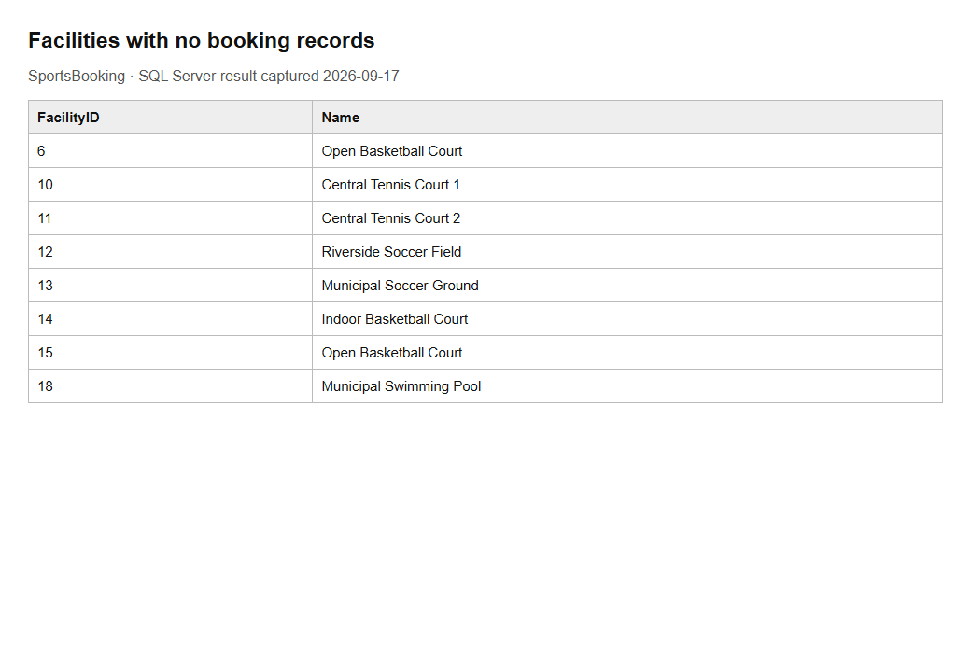
Figure 3.7. Query 6 returned 8 rows.

3.3.7 Preferred sports for each member
The link table joins members to their selected sport categories. This query demonstrates the many-to-many association.
SELECT m.Name AS Member,t.TypeName AS PreferredSport
FROM SportPreference s
JOIN Member m ON m.MemberID=s.MemberID
JOIN FacilityType t ON t.TypeID=s.TypeID
ORDER BY m.MemberID,t.TypeName;

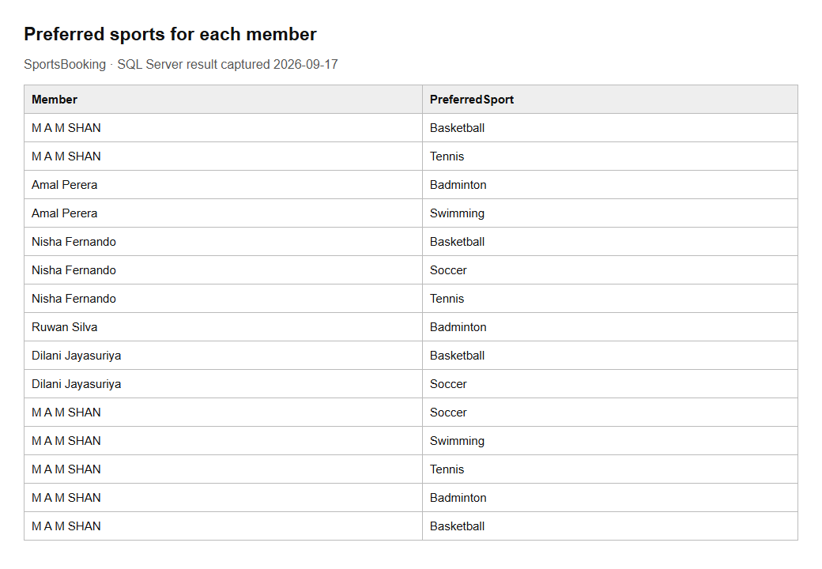
Figure 3.8. Query 7 returned 15 rows.

3.3.8 Latest guest inquiries
The latest five inquiries are returned first, with InquiryID resolving ties in DateSent. This is an internal SQL report; the application does not expose inquiry records publicly.
SELECT TOP (5) InquiryID,GuestName,Message,DateSent
FROM Inquiry
ORDER BY DateSent DESC,InquiryID DESC;

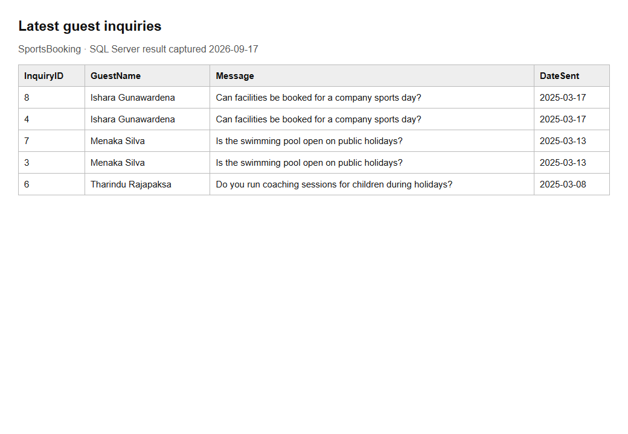
Figure 3.9. Query 8 returned 5 rows.

4. Implementation of the Web-Based Application

4.1 System Architecture
The project uses a simple MVC structure. Models describe the database entities and form inputs, controllers process requests, and Razor views render HTML. SportsContext is injected into controllers and uses the SQL Server provider to query and save data. EF Core reverse engineering produces entity classes and a DbContext from an existing database (Microsoft, n.d.-b).
Browser request
-> Controller action
-> Form view model and validation
-> SportsContext and EF Core
-> SQL Server
-> Razor view returned to the browser

Area | Files and purpose
Controllers | Home, Account, Facility, Booking, Review and Inquiry handle public/member routes.
Models | Seven entity classes; RegisterViewModel, FacilitySearchViewModel, BookingViewModel and ReviewViewModel handle form data.
Data | SportsContext contains table mappings and relationships.
Views | Razor pages share _Layout.cshtml and Bootstrap styling.
Program.cs | Registers MVC, SQL Server and sessions; serves static files and maps routes.
tests | SmokeTest.ps1 executes HTTP requests and checks saved database records.

MVC separates request handling from page presentation (Microsoft, n.d.-a). Session stores MemberID and MemberName after a valid login. Protected actions check MemberID before accessing data. AddDistributedMemoryCache, AddSession and UseSession configure this prototype’s in-memory sessions (Microsoft, n.d.-c). Restarting the app clears them.
builder.Services.AddDbContext<SportsContext>(options =>
options.UseSqlServer(builder.Configuration.GetConnectionString("SportsDb")));

builder.Services.AddDistributedMemoryCache();
builder.Services.AddSession(options =>
{
options.IdleTimeout = TimeSpan.FromMinutes(30);
options.Cookie.HttpOnly = true;
});

View models contain only editable fields. MemberId and booking Status are set by the server. Required fields, maximum lengths and numeric ranges are checked through data annotations and ModelState.IsValid (Microsoft, n.d.-d). POST forms include anti-forgery tokens.

4.2 Home Page
The home page introduces community sports, links to facility search and reviews, and presents separate member-login and new-registration areas. Navigation changes after login to include My Bookings and logout. Contact Us remains available to both members and guests.
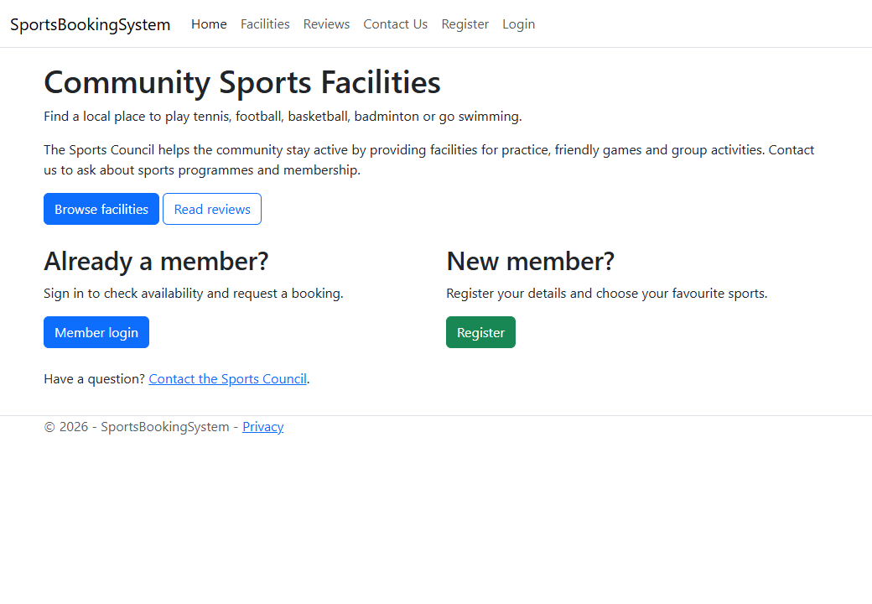
Figure 4.1. Home page with login and registration options.
@if (Context.Session.GetInt32("MemberID") == null)
{
<a asp-controller="Account" asp-action="Login">Member login</a>
<a asp-controller="Account" asp-action="Register">Register</a>
}

4.3 Member Functionality

4.3.1 Sign In
AccountController checks that email and password have been supplied, looks up the member and displays an error when the details do not match. A valid login stores the member identity in session and redirects to Facility/Search. Logout is a POST action that clears the session.
[HttpPost]
[ValidateAntiForgeryToken]
public async Task<IActionResult> Login(string email, string password)
{
if (string.IsNullOrWhiteSpace(email) || string.IsNullOrWhiteSpace(password))
{
ModelState.AddModelError("", "Please enter your email and password.");
return View();
}

var member = await _context.Members
.FirstOrDefaultAsync(m => m.Email == email.Trim() && m.Password == password);

if (member == null)
{
ModelState.AddModelError("", "Invalid email or password.");
return View();
}

HttpContext.Session.SetInt32("MemberID", member.MemberId);
HttpContext.Session.SetString("MemberName", member.Name);

return RedirectToAction("Search", "Facility");

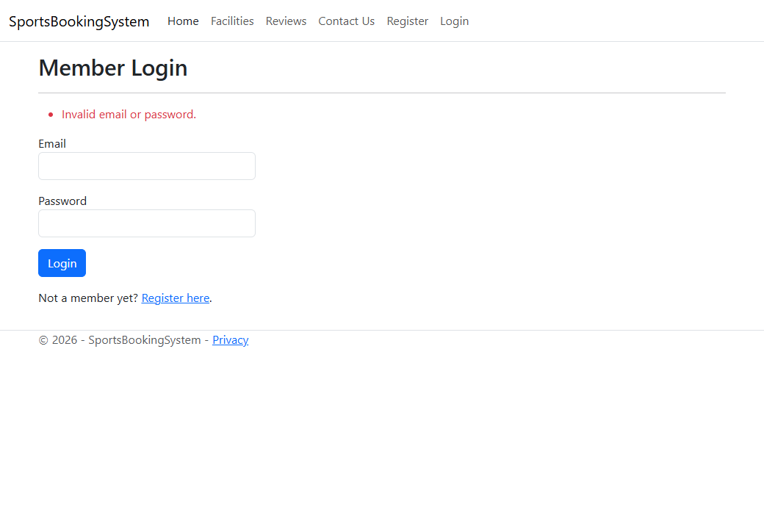
Figure 4.2. Invalid credentials produce a validation message.
The existing prototype compares plain-text passwords. This is a recorded limitation, not a production authentication design. Password hashing, account lockout and recovery are future improvements.

4.3.2 Registration
The registration form captures name, email, phone, address, password and at least one preferred sport. It rejects duplicate email addresses and sport IDs that do not exist. Repeated sport IDs are removed with Distinct(). The Member and its SportPreferences are saved in one SaveChangesAsync call, then the member is signed in.
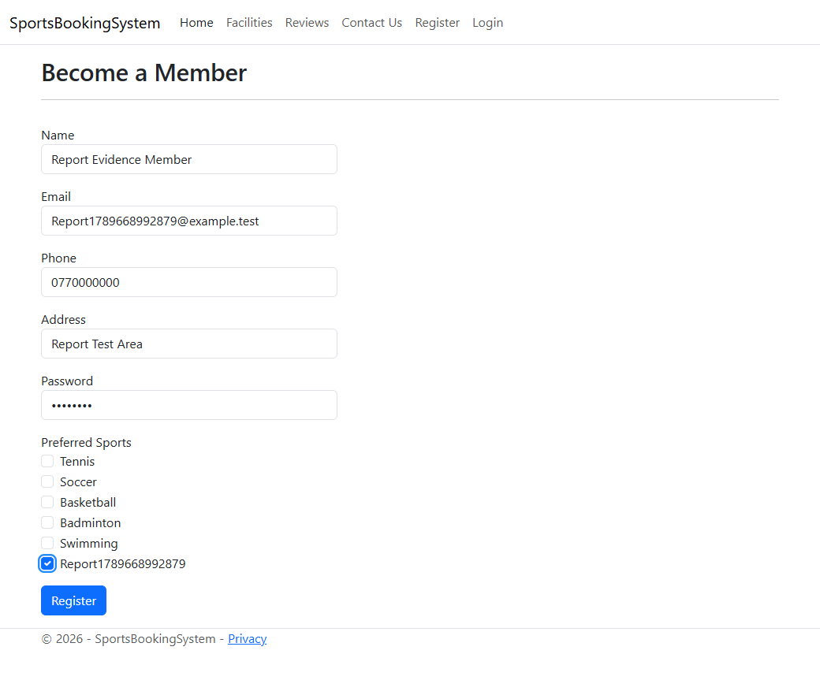
Figure 4.3. Completed registration form with a preferred sport.
foreach (var typeId in model.SelectedSports)
{
member.SportPreferences.Add(new SportPreference { TypeId = typeId });
}
_context.Members.Add(member);
await _context.SaveChangesAsync();

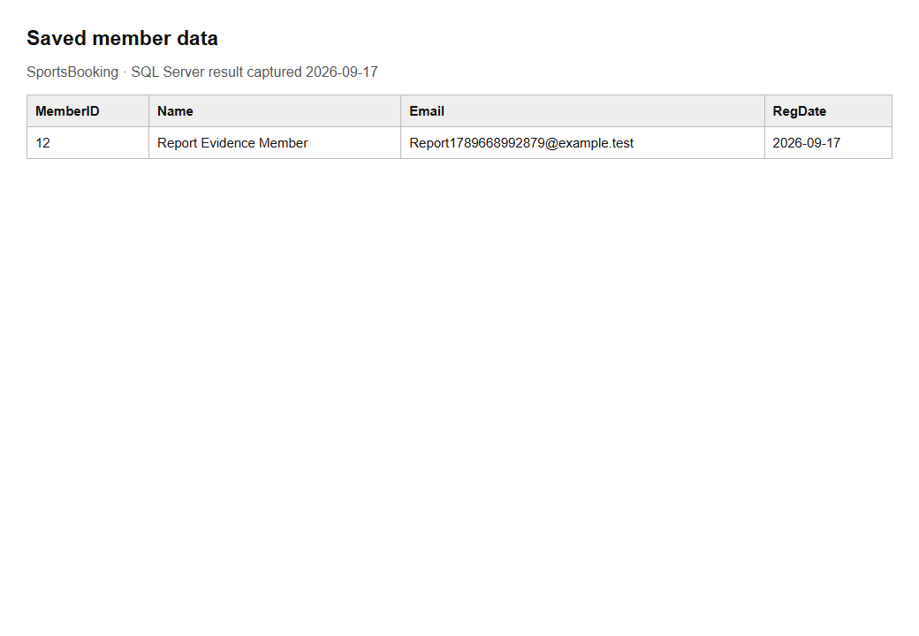
Figure 4.4. Saved test member row, with the password excluded.
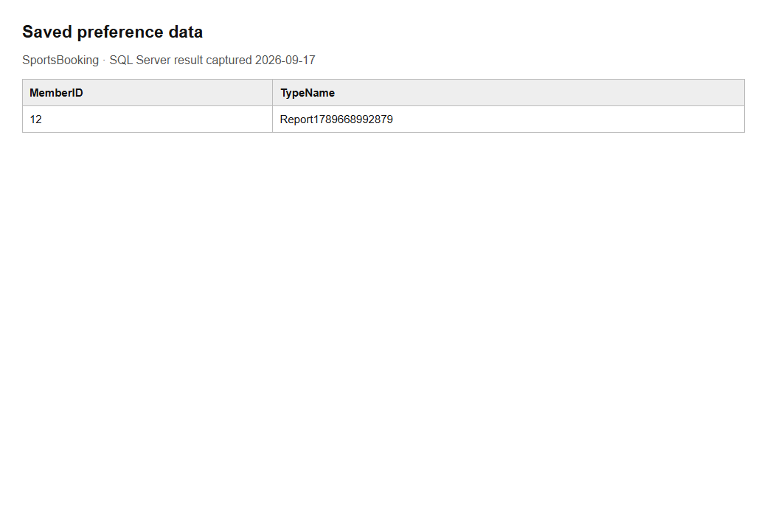
Figure 4.5. Preferred sport saved for the same member.

4.3.3 Facility Search
Members can combine sport, location, date and time filters. Empty filters are ignored. Both times are required when a time filter is used, and an end time must follow the start time. A query excludes any facility with an overlapping non-cancelled booking. The page shows no-results feedback when no venue matches.
if (!ModelState.IsValid) return View(model);

var facilities = _context.Facilities.Include(f => f.Type).AsQueryable();
if (model.TypeId.HasValue) facilities = facilities.Where(f => f.TypeId ==
model.TypeId);
if (!string.IsNullOrWhiteSpace(model.Location))
facilities = facilities.Where(f => f.Location != null &&
f.Location.Contains(model.Location.Trim()));
if (model.Date.HasValue)
{
var start = model.Date.Value.ToDateTime(model.StartTime ?? TimeOnly.MinValue);
var end = model.EndTime.HasValue ?
model.Date.Value.ToDateTime(model.EndTime.Value) : start.AddDays(1);
facilities = facilities.Where(f => !f.Bookings.Any(b => b.Status != "Cancelled" &&
b.BookingDate == model.Date
&& (b.StartTime == null || b.EndTime == null || (b.StartTime < end &&
b.EndTime > start))));
}
model.Facilities = await facilities.OrderBy(f => f.Name).ToListAsync();

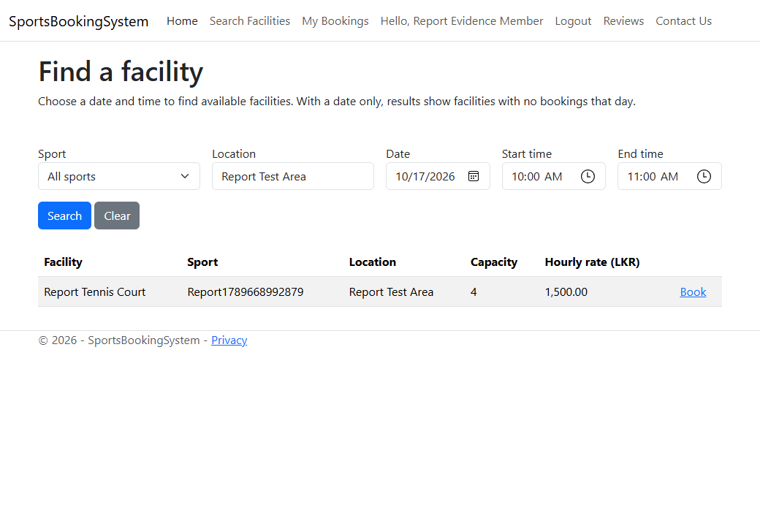
Figure 4.6. Member search with availability, price and booking link.
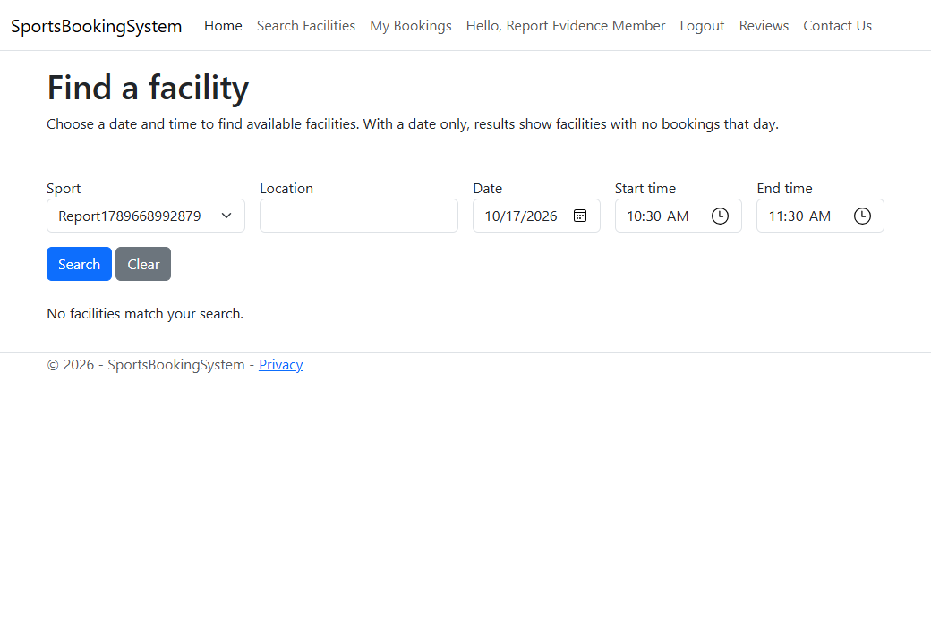
Figure 4.7. The same test facility is excluded when its slot is booked.

4.3.4 Facility Booking
The form accepts a facility, date, start time and end time. MemberID comes from the session and cannot be chosen through the form. The controller rejects past times, invalid intervals, nonexistent facilities and clashes. New requests are saved as Pending. The My Bookings query filters by the logged-in member, so it does not list another member’s bookings.
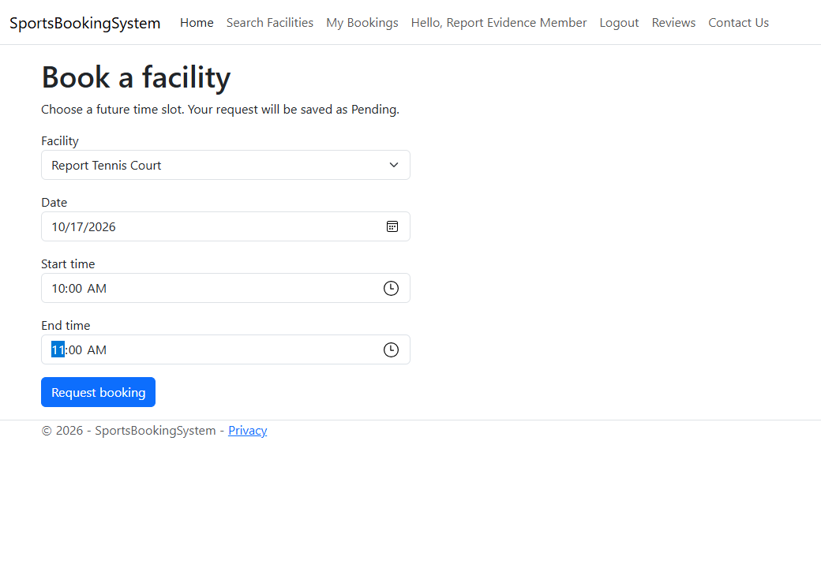
Figure 4.8. Booking form before submission.
await using var transaction = await _context.Database
.BeginTransactionAsync(IsolationLevel.Serializable);
var clash = await _context.Bookings.AnyAsync(b =>
b.FacilityId == model.FacilityId && b.BookingDate == model.BookingDate
&& b.Status != "Cancelled"
&& (b.StartTime == null || b.EndTime == null
|| (b.StartTime < end && b.EndTime > start)));

The serializable transaction keeps the availability check and insert together. The overlap rule uses start < requested end and end > requested start. Therefore 10:00–11:00 and 11:00–12:00 do not overlap. Load testing and deadlock retry handling are not included in the current prototype.
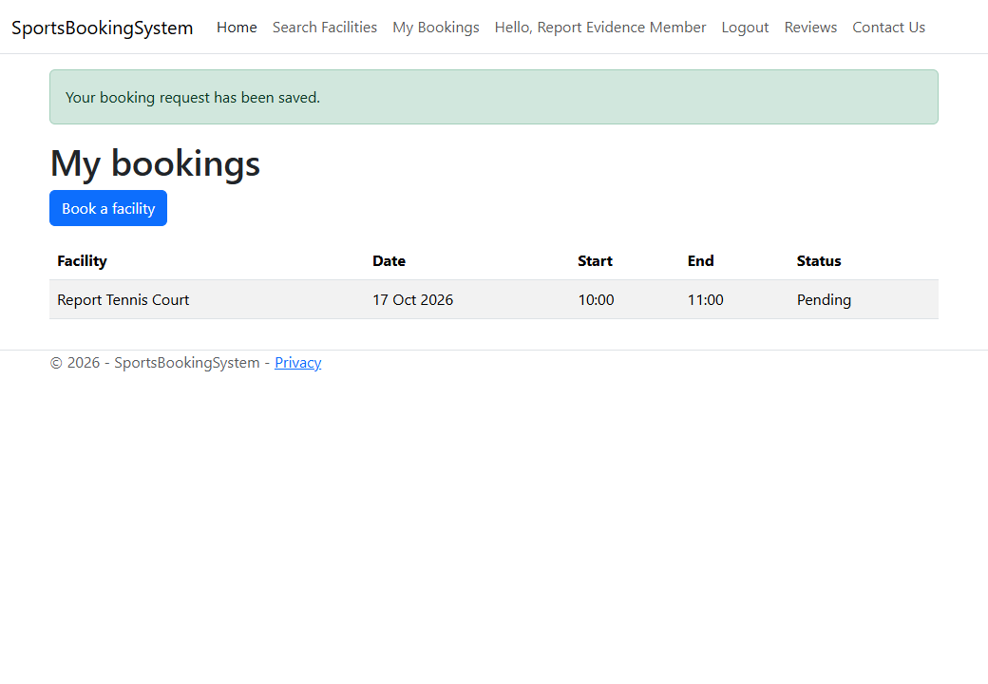
Figure 4.9. Saved booking displayed in My Bookings.
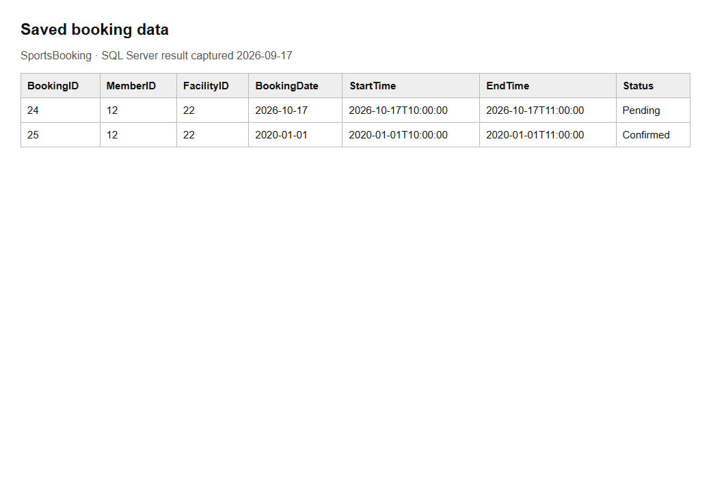
Figure 4.10. Saved booking rows used for screenshot evidence. The 2020 Confirmed row was deliberately seeded to test reviews.

4.3.5 Review Submission
A member can review only a facility with a Confirmed booking that has already ended. The form provides eligible facilities, an integer rating from 1 to 5 and optional comments up to 255 characters. The server supplies MemberID and ReviewDate. The database also enforces the rating range through CK_Review_Rating.
if (!await _context.Bookings.AnyAsync(b =>
b.MemberId == memberId && b.FacilityId == model.FacilityId
&& b.Status == "Confirmed" && b.EndTime < DateTime.Now))
{
ModelState.AddModelError("FacilityId",
"You can review a facility after a confirmed booking has ended.");
}

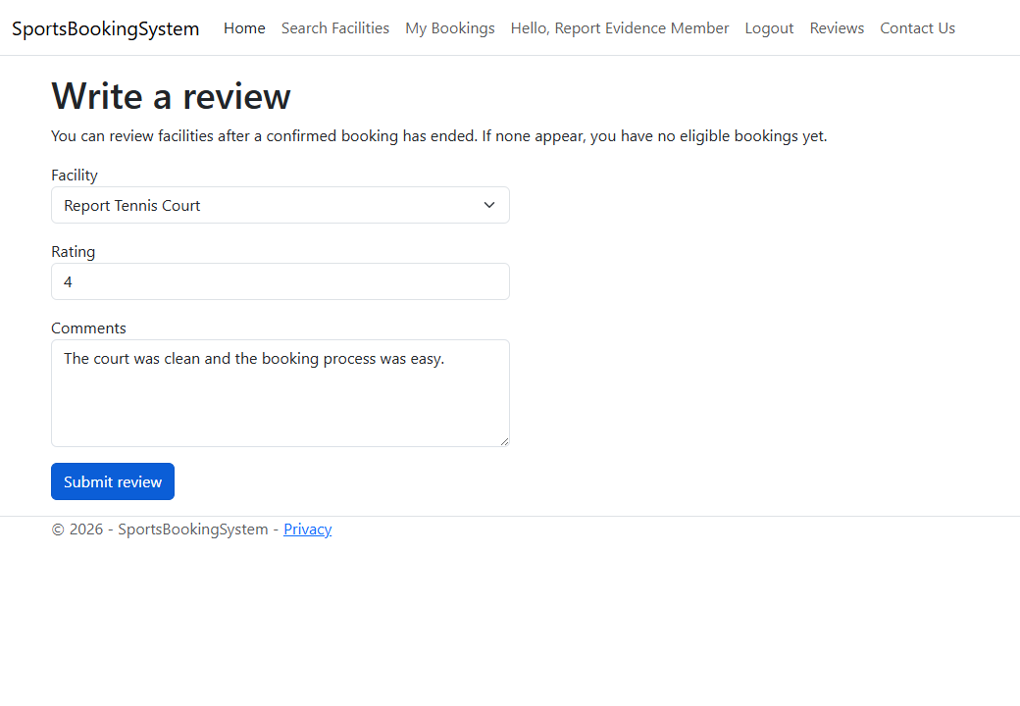
Figure 4.11. Review form for an eligible facility.
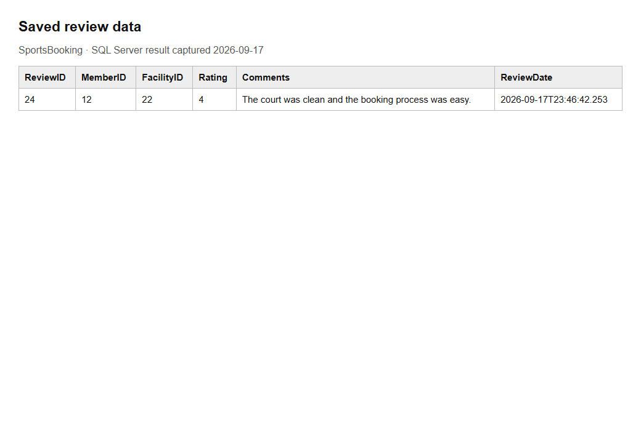
Figure 4.12. Saved review with its integer rating and date.

4.4 Guest Functionality

4.4.1 Restricted Search
Guests can use the search filters to see facility names, sport types, locations and broad availability. They do not see member-only booking links, capacity or hourly-rate columns. This display rule is backed by server checks on booking and review creation. Direct requests to those actions redirect guests to login.
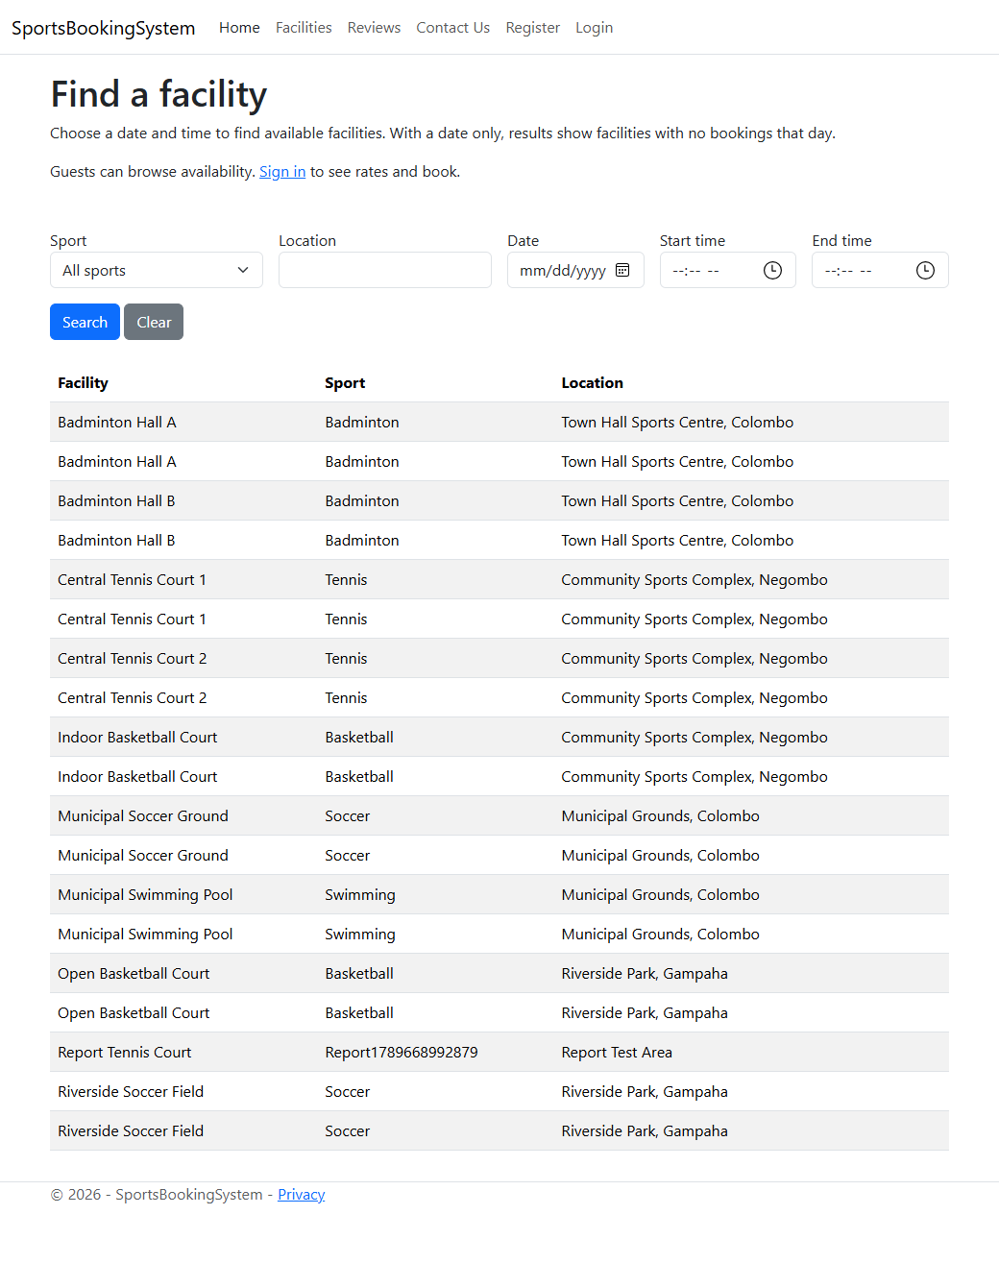
Figure 4.13. Guest search without member-only booking controls.
var memberId = HttpContext.Session.GetInt32("MemberID");
if (memberId == null)
return RedirectToAction("Login", "Account");

Unused scaffolded Member, FacilityType and SportPreference controllers are marked NonController. Facility, Booking, Review and Inquiry controllers expose only the intended routes. Old management URLs return 404; hiding links alone would not protect the underlying actions.

4.4.2 Review Search
Guests can read reviews without an account. Optional filters select a facility and/or rating. The query includes Facility and Member so the page shows meaningful names instead of foreign-key numbers. The public page has no edit or delete links.
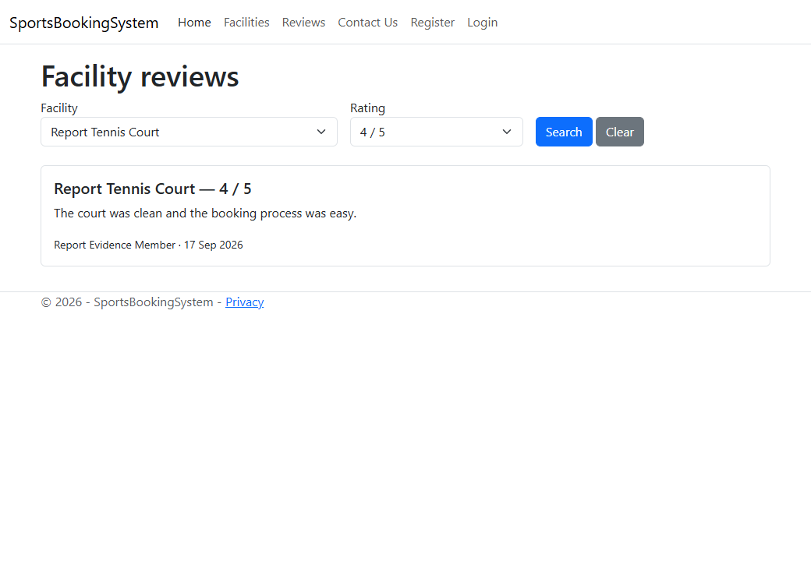
Figure 4.14. A guest reads the submitted four-star review.
var reviews = _context.Reviews
.Include(r => r.Facility).Include(r => r.Member).AsQueryable();
if (facilityId.HasValue)
reviews = reviews.Where(r => r.FacilityId == facilityId);
if (rating.HasValue)
reviews = reviews.Where(r => r.Rating == rating.Value);

4.4.3 Membership Registration
The home page and guest navigation both link to Account/Register. Guests use the same registration form described in Section 4.3.2, which includes the required name and email as well as contact details and sport preferences. After a successful submission the guest becomes a member and reaches the member search page.

4.4.4 Send Inquiry
Inquiry/Create is public. Name, a valid email and message are required. The application sets DateSent, saves the row and displays a confirmation. Inquiry does not need a MemberID. The application no longer exposes a public list of other people’s inquiries.
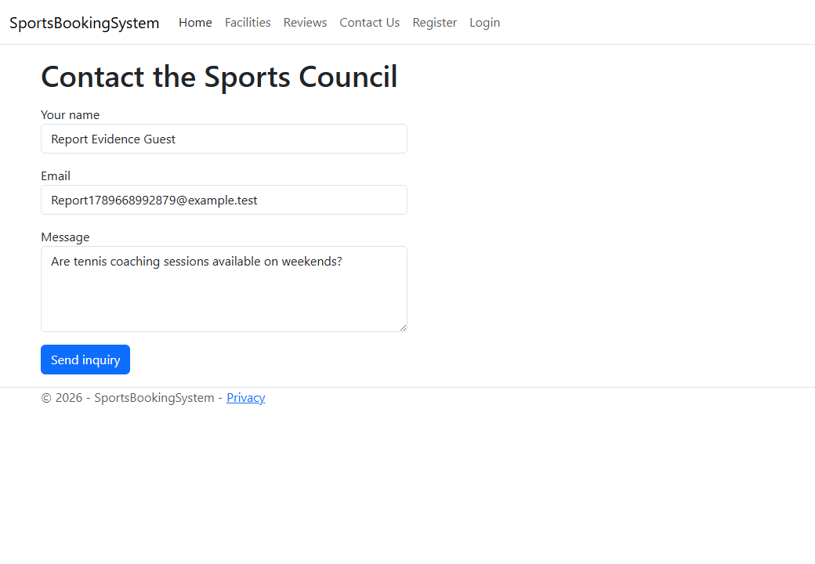
Figure 4.15. Guest inquiry form.
if (!ModelState.IsValid) return View(inquiry);
inquiry.DateSent = DateOnly.FromDateTime(DateTime.Today);
_context.Inquiries.Add(inquiry);
await _context.SaveChangesAsync();
TempData["Success"] = "Your inquiry has been sent to the Sports Council.";

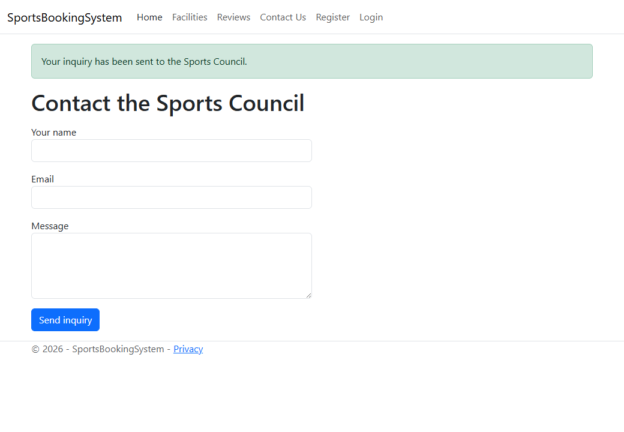
Figure 4.16. Confirmation after saving an inquiry.
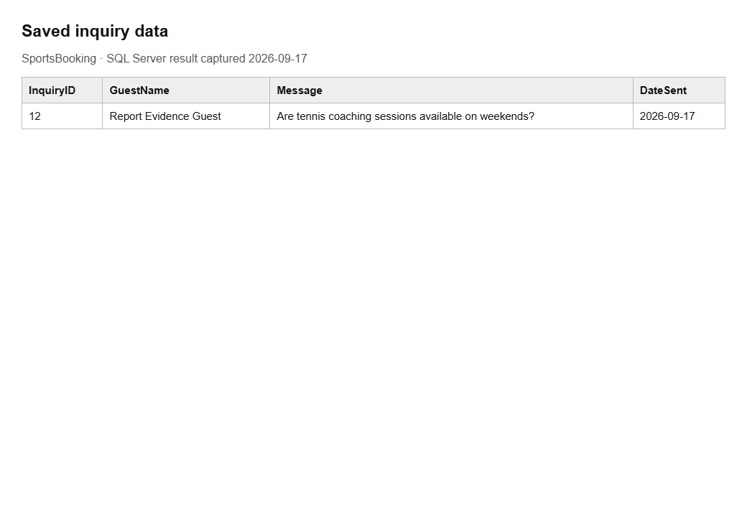
Figure 4.17. Corresponding Inquiry row in SQL Server.

5. Testing
Testing used the running application and local SQL Server database on 17 September 2026. The PowerShell script tests HTTP routes, validation and persistence. A separate headless Microsoft Edge run checks rendered pages and captures screenshots. Both use uniquely identified temporary records and remove them afterwards. The screenshots show deliberate test data, including a past Confirmed booking needed for review eligibility.
ID | Test and data | Expected result | Actual result | Status
T01 | Home page  GET / | Sports information visible | Home heading returned | Pass
T02 | Guest facility search  Type filter; no login | Browse without rate or booking details | Facility visible; rate column absent | Pass
T03 | Guest booking form  GET /Booking/Create | Redirect to login | Login redirect | Pass
T04 | Guest booking list  GET /Booking/MyBookings | Redirect to login | Login redirect | Pass
T05 | Guest review form  GET /Review/Create | Redirect to login | Login redirect | Pass
T06 | Member management  GET /Member | Route disabled | 404 | Pass
T07 | Facility creation  GET /Facility/Create | Route disabled | 404 | Pass
T08 | Facility editing  GET /Facility/Edit/1 | Route disabled | 404 | Pass
T09 | Review deletion  GET /Review/Delete/1 | Route disabled | 404 | Pass
T10 | Inquiry list  GET /Inquiry | Route disabled | 404 | Pass
T11 | Preference management  GET /SportPreference | Route disabled | 404 | Pass
T12 | Sport management  GET /FacilityType | Route disabled | 404 | Pass
T13 | Invalid login  Unknown email, wrong password | Display error | Invalid credentials message | Pass
T14 | Invalid sport  SelectedSports=999999 | Reject unknown sport | Validation message | Pass
T15 | Registration  Valid new details and sport | Save and sign in | Redirect to search | Pass
T16 | Preference insert  New member and sport IDs | One matching row | SQL count = 1 | Pass
T17 | Duplicate email  Register same email again | Reject duplicate | Already registered message | Pass
T18 | Valid login  New test email, correct password | Sign in | Redirect to search | Pass
T19 | Member search  Logged-in type search | Show rate and Book link | Both shown | Pass
T20 | Booking save  Future date, 10:00–11:00 | Save booking | Confirmation shown | Pass
T21 | Forged booking fields  MemberId=999999, Status=Confirmed | Use session ID and Pending | SQL verified server values | Pass
T22 | Overlap  Existing 10:00–11:00; request 10:30–11:30 | Reject clash | Already booked message | Pass
T23 | Availability search  Search booked 10:30–11:30 | Exclude booked facility | No results | Pass
T24 | Adjacent slot  Request 11:00–12:00 | Allow booking | Confirmation shown | Pass
T25 | Invalid interval  Start 12:00, end 11:00 | Reject interval | End-time validation | Pass
T26 | Past booking  1 January 2020 | Reject past time | Future-time validation | Pass
T27 | Review before visit  Only future Pending booking | Reject review | Eligibility validation | Pass
T28 | Invalid rating  Eligible visit, rating 6 | Reject out-of-range value | Range validation | Pass
T29 | Valid review  Eligible visit, rating 4 | Save review | Confirmation shown | Pass
T30 | Review filter  Facility and rating=4 | Matching review visible | Expected content returned | Pass
T31 | Empty inquiry  Empty Message | Reject required field | Required-field validation | Pass
T32 | Inquiry submit  Valid name, email and message | Save and confirm | Confirmation shown | Pass
T33 | Inquiry persistence  Query saved inquiry | One row with today’s date | SQL count = 1 | Pass
T34 | Logout  POST /Account/Logout | Clear session | Protected page redirects | Pass

5.1 Test Evidence
Figures 4.2–4.17 support the login, registration, booking, review and inquiry tests. The image below records the overlap validation from T22. The saved test script contains the repeatable requests and SQL assertions. The browser run separately confirms guest review access using a fresh, unauthenticated browser context.
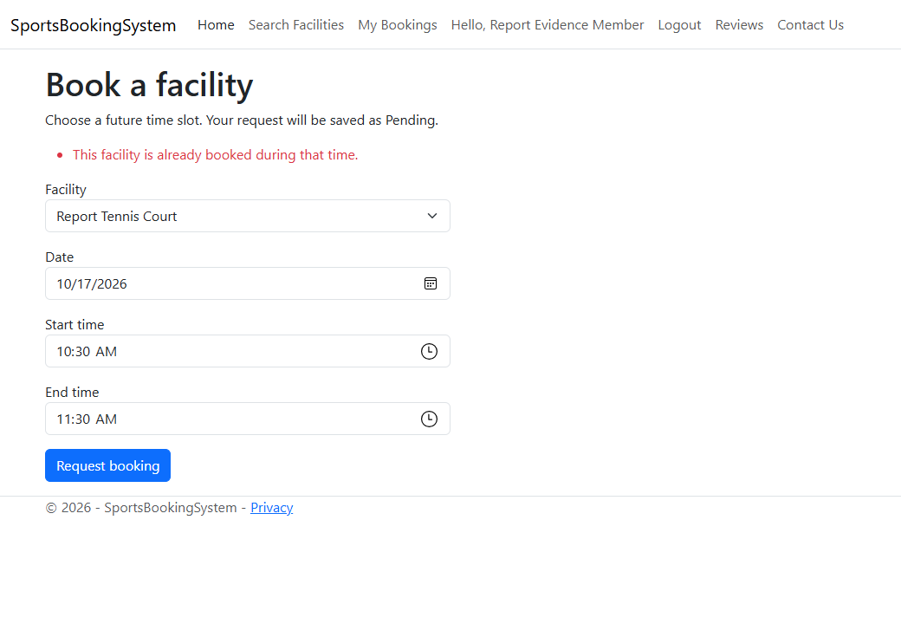
Figure 5.1. T22: an overlapping booking produces an error.
Browser check | Result
Guest redirected from booking form | Pass
Invalid login rejected | Pass
Registration opens member search | Pass
Booking confirmation displayed | Pass
Overlapping booking rejected | Pass
Booked slot absent from search | Pass
Review saved | Pass
Guest reads saved review | Pass
Inquiry confirmation displayed | Pass

5.2 Summary of Testing
All 34 automated HTTP/database checks passed. All nine additional browser checks passed. The project built with zero warnings and zero errors. These results cover the tested prototype flows; they do not establish production security, performance under load or complete browser compatibility.
Fault found | Correction | Retest
Search and My Bookings links targeted missing actions. | Implemented Facility/Search and Booking/MyBookings. | T15, T18–T20 passed.
Scaffolded booking allowed posted identity/status fields. | Used a form view model; set identity and Pending status on the server. | T21 passed.
Booking ID mapping did not match SQL identity columns. | BookingID generated on add; MemberID supplied normally. | T20 inserted a booking successfully.
Review rating and report disagreed; CHECK constraints were absent. | Converted valid ratings to INT, updated EF and added both checks. | T28–T29 passed; database metadata verified.
CSS did not load when running without a launch profile. | Added UseStaticFiles before routing. | Bootstrap resource returned HTTP 200; screenshots recaptured.
Unused scaffolded routes exposed management operations. | Disabled unused controllers and removed public CRUD actions. | T06–T12 returned 404.

Remaining limits include plain-text passwords, no automated booking approval, repeated reviews, no pagination and no concurrent-load test. The booking transaction uses serializable isolation, but a production version should handle deadlocks and retries. Form checks reject invalid user inputs; further database checks for times, rates and capacity would strengthen direct SQL writes.

6. Further Discussion and Reflection
The main design decision in this project was to keep SQL Server as the source of the data model. This made it possible to compare the database diagram, SQL script, entity classes and report directly. It also exposed a weakness in relying on generated files without checking them: the Booking key mapping and Review rating type did not match the intended design.
For this prototype, I kept the controllers and Razor pages simple. Each form has a small view model and the controller handles its validation and database operation. This makes it easier to follow the booking flow from the submitted date and time to the final Booking row. A larger application would need more separation of business rules and reusable authorization checks.
The booking overlap rule was an important part of the implementation. Comparing only the start times would miss partially overlapping reservations. The implemented rule compares both ends of each interval. Tests confirmed that an overlapping request is rejected while an adjacent booking is accepted. The server also supplies MemberID and Status, which prevents a member from changing them by editing form data.
The review flow links feedback to a completed Confirmed booking. This makes the meaning of a review clearer, but it also exposes a limitation in the workflow: the prototype has no approval screen. New requests stay Pending until the database is updated manually. An administrative approval page is therefore a useful next feature.
Testing revealed that a successful build does not prove the whole page works. The CSS problem appeared only when the application was opened for screenshots without a launch profile. The application also needed checks that direct URLs were blocked for guests, because removing a navigation link alone does not protect an action.
The project would need several improvements before public use. Passwords should be hashed, session-based identity checks should be replaced or strengthened with standard authentication, booking approvals should be managed through a protected interface, and confirmations could be sent by email. Search paging and broader concurrency tests would help with larger data sets. The practical lesson from the verified changes is to keep the schema, code, screenshots and written claims consistent, and to support each main feature with a repeatable test.

7. Conclusion
The prototype provides member registration, login, facility search, booking requests, reviews and guest inquiries using ASP.NET Core MVC and SQL Server. The seven-table schema supports the required relationships, and the rating and status rules are enforced in the database. The tested application passed 34 HTTP/database checks and nine browser checks. It remains a coursework prototype with the limitations discussed above.

8. References
Microsoft (n.d.-a). Overview of ASP.NET Core MVC. Available at: https://learn.microsoft.com/en-us/aspnet/core/mvc/overview?view=aspnetcore-10.0 (Accessed: 17 September 2026).
Microsoft (n.d.-b). Reverse Engineering. Entity Framework Core. Available at: https://learn.microsoft.com/en-us/ef/core/managing-schemas/scaffolding/ (Accessed: 17 September 2026).
Microsoft (n.d.-c). Session in ASP.NET Core. Available at: https://learn.microsoft.com/en-us/aspnet/core/fundamentals/app-state?view=aspnetcore-10.0 (Accessed: 17 September 2026).
Microsoft (n.d.-d). Model validation in ASP.NET Core MVC. Available at: https://learn.microsoft.com/en-us/aspnet/core/mvc/models/validation?view=aspnetcore-10.0 (Accessed: 17 September 2026).
Oracle (n.d.). Data Modeler Concepts and Usage. SQL Developer Data Modeler 24.3 User’s Guide. Available at: https://docs.oracle.com/en/database/oracle/sql-developer-data-modeler/24.3/dmdug/data-modeler-concepts-usage.html (Accessed: 17 September 2026).
Coursework brief (undated). Community Sports Facilities Booking System. Supplied assignment document.
Project evidence: SportsBookingSystem source files, ER.dmd, ERD.png, Logical.png, ERDB File.ddl, SQL metadata and query results, SmokeTest.ps1 output and browser screenshots captured on 17 September 2026.

9. Appendices

Appendix A Full database schema
This script recreates the verified schema in an empty database. It is a schema export, not an instruction to drop or recreate the existing SportsBooking database.

Member
CREATE TABLE Member (
MemberID INT IDENTITY(1,1) NOT NULL,
Name VARCHAR(255) NOT NULL,
Email VARCHAR(255) NOT NULL,
Phone VARCHAR(255) NULL,
Address VARCHAR(255) NULL,
Password VARCHAR(255) NOT NULL,
RegDate DATE NULL,
CONSTRAINT Member__UN UNIQUE (Email),
CONSTRAINT Member_PK PRIMARY KEY (MemberID)
);
GO

FacilityType
CREATE TABLE FacilityType (
TypeID INT IDENTITY(1,1) NOT NULL,
TypeName VARCHAR(255) NOT NULL,
CONSTRAINT FacilityType_PK PRIMARY KEY (TypeID)
);
GO

Facility
CREATE TABLE Facility (
FacilityID INT IDENTITY(1,1) NOT NULL,
Name VARCHAR(255) NOT NULL,
TypeID INT NOT NULL,
Location VARCHAR(255) NULL,
Capacity INT NULL,
HourlyRate DECIMAL(25,2) NULL,
CONSTRAINT Facility_PK PRIMARY KEY (FacilityID),
CONSTRAINT Facility_FacilityType_FK FOREIGN KEY (TypeID) REFERENCES FacilityType(TypeID)
);
GO

Booking
CREATE TABLE Booking (
BookingID INT IDENTITY(1,1) NOT NULL,
MemberID INT NOT NULL,
FacilityID INT NOT NULL,
BookingDate DATE NOT NULL,
StartTime DATETIME NULL,
EndTime DATETIME NULL,
Status VARCHAR(255) NOT NULL,
CONSTRAINT Booking_PK PRIMARY KEY (BookingID),
CONSTRAINT Booking_Facility_FK FOREIGN KEY (FacilityID) REFERENCES Facility(FacilityID),
CONSTRAINT Booking_Member_FK FOREIGN KEY (MemberID) REFERENCES Member(MemberID),
CONSTRAINT CK_Booking_Status CHECK ([Status]='Cancelled' OR [Status]='Confirmed' OR
[Status]='Pending')
);
GO

Review
CREATE TABLE Review (
ReviewID INT IDENTITY(1,1) NOT NULL,
MemberID INT NOT NULL,
FacilityID INT NOT NULL,
Rating INT NOT NULL,
Comments VARCHAR(255) NULL,
ReviewDate DATETIME NULL,
CONSTRAINT Review_PK PRIMARY KEY (ReviewID),
CONSTRAINT Review_Facility_FK FOREIGN KEY (FacilityID) REFERENCES Facility(FacilityID),
CONSTRAINT Review_Member_FK FOREIGN KEY (MemberID) REFERENCES Member(MemberID),
CONSTRAINT CK_Review_Rating CHECK ([Rating]>=(1) AND [Rating]<=(5))
);
GO

SportPreference
CREATE TABLE SportPreference (
SportPreferenceID INT IDENTITY(1,1) NOT NULL,
MemberID INT NOT NULL,
TypeID INT NOT NULL,
CONSTRAINT SportPreference__UN UNIQUE (MemberID, TypeID),
CONSTRAINT SportPreference_PK PRIMARY KEY (SportPreferenceID),
CONSTRAINT SportPreference_FacilityType_FK FOREIGN KEY (TypeID) REFERENCES
FacilityType(TypeID),
CONSTRAINT SportPreference_Member_FK FOREIGN KEY (MemberID) REFERENCES Member(MemberID)
);
GO

Inquiry
CREATE TABLE Inquiry (
InquiryID INT IDENTITY(1,1) NOT NULL,
GuestName VARCHAR(255) NULL,
Email VARCHAR(255) NULL,
Message VARCHAR(255) NULL,
DateSent DATE NULL,
CONSTRAINT Inquiry_PK PRIMARY KEY (InquiryID)
);
GO

Appendix B Sample insert script
This example inserts one related set of sample records in a test database. The existing database’s wider sample data and actual row counts are documented in Section 3.2.
SET XACT_ABORT ON;
BEGIN TRANSACTION;
INSERT INTO Member (Name,Email,Phone,Address,Password,RegDate)
VALUES ('Sample Member','coursework.sample@example.test','0770000000',
'Negombo','Sample123!',CAST(GETDATE() AS DATE));
DECLARE @MemberID INT = SCOPE_IDENTITY();
INSERT INTO FacilityType (TypeName) VALUES ('Sample Tennis');
DECLARE @TypeID INT = SCOPE_IDENTITY();
INSERT INTO Facility (Name,TypeID,Location,Capacity,HourlyRate)
VALUES ('Sample Tennis Court',@TypeID,'Negombo',4,1500.00);
DECLARE @FacilityID INT = SCOPE_IDENTITY();
INSERT INTO SportPreference (MemberID,TypeID) VALUES (@MemberID,@TypeID);
INSERT INTO Booking (MemberID,FacilityID,BookingDate,StartTime,EndTime,Status)
VALUES (@MemberID,@FacilityID,'2026-08-01','2026-08-01T09:00:00',
'2026-08-01T10:00:00','Confirmed');
INSERT INTO Review (MemberID,FacilityID,Rating,Comments,ReviewDate)
VALUES (@MemberID,@FacilityID,4,'The court was clean.','2026-08-01T11:00:00');
INSERT INTO Inquiry (GuestName,Email,Message,DateSent)
VALUES ('Sample Guest','guest@example.test','Are weekend sessions available?',
CAST(GETDATE() AS DATE));
COMMIT;

Appendix C Running and verifying the project
Open SportsBookingSystem.csproj in Visual Studio or use the commands below. The configured database is SportsBooking on 127.0.0.1 with Windows authentication. SQL Server must be running, and the Windows account must have access.
dotnet build
dotnet run --no-launch-profile --urls http://127.0.0.1:5187
# Run in a second PowerShell window.
.\tests\SmokeTest.ps1

The test script creates and removes only its uniquely named temporary member, facility, category, bookings, reviews and inquiry records. Its SQL cleanup runs in finally. It should be run against a local coursework/test database.

Appendix D Full controller code
The complete controller source is supplied with the project. The main report includes the relevant excerpts to keep the explanations readable. Files: Controllers/AccountController.cs, FacilityController.cs, BookingController.cs, ReviewController.cs and InquiryController.cs. Program.cs contains service and middleware setup.

